## Install Pre-reqs

* Office 365 Logging can take hours to enable, so setup at least a couple days prior to events
* Make sure that Exchange Online Module is installed on your local machine. You can install it from <https://www.powershellgallery.com/packages/ExchangeOnlineShell/2.0.3.2>

## Step 1 - Create new Demo tenant

* Go to admin.microsoft.com
* Go to **Billing ->Purchase Services** and Search on Power Apps per User Plan – Click Get free trial
* Go to **Billing ->Purchase Services** and Search on Power Apps per user Plan - – Click Get free trial - assign license to the admin account
* You need to add Common Data Service capacity. If you have a Microsoft contact check with them for a token, otherwise you can purchase a single Power Automate per user license which will provide 10gb of capacity. Setup will fail without this capacity.
* Navigate to aka.ms/ppac and make sure you can see the default environment
* Click on the default environment and select Edit in the details section – change the environment name to User and Team Productivity and click Save

## Step 2 - Run Setup Script

* From Windows PowerShell ISE open **Setup.ps1**
* Run the script – you will be prompted for your tenant admin account – **make sure to provide the account only for your demo tenant admin as all users will be disabled other than admin as part of the script execution.**
* Run the **Start-AdminInADay-Setup** it will prompt you to provide the following information
* Example: **Start-AdminInADay-Setup** -TenantName 'MX60265ABC' -CDSLocation 'unitedstates' -UserCount 10 -APIUrl 'https://admin.services.crm.dynamics.com'
* You can get parameter help using **get-help Start**-AdminInADay -Detailed
* If a step fails, you can rerun the Start-AdminInADay-Setup using the -Restart True parameter. As it runs you may get a few “Already exists errors” and that is ok
* Note: If you have incompatible PowerShell modules already installed you might get an error prompting you to run CleanupOldModules.ps1. Close all PowerShell sessions and run this script which will remove all PowerShell modules used by the setup script so the setup script can then install the versions it requires.

## Step 3 - Share the Device Ordering App

* In the Device Ordering Development environment
* Share the Device Ordering app with the Lab Admin Team using the following options

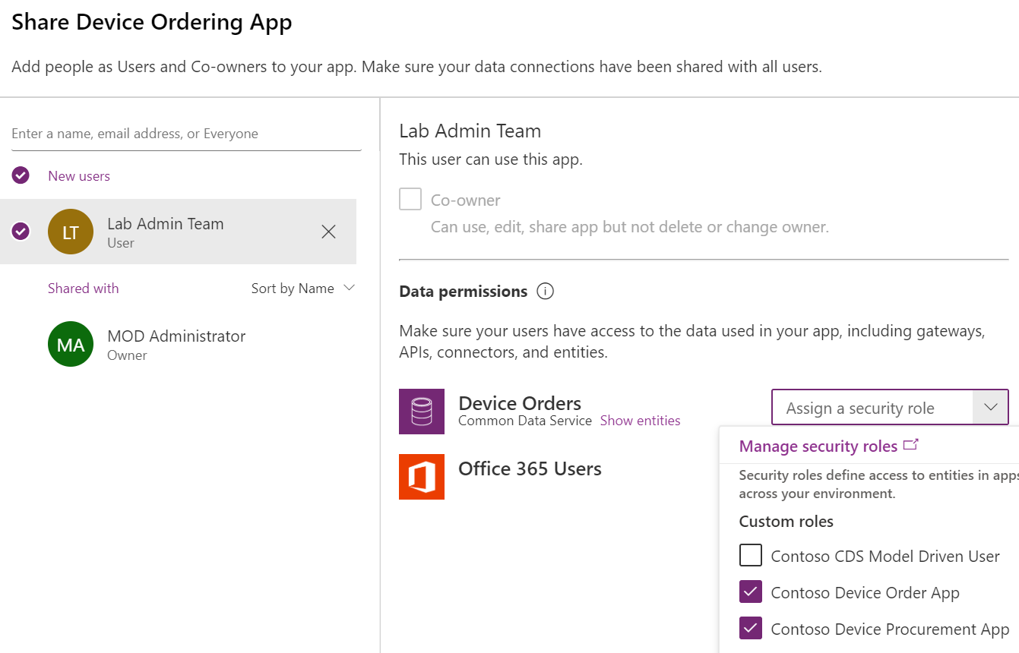

## Step 4 - Create Dummy Apps and Flows

* In PowerShell ISE change directory to the **GenereateAppsAndFlows** folder and load **import.ps1**
* Edit the environment and user/password and then run, it will generate apps and flows in about 15 minutes
* Share the allentest001 app with everyone in the tenant

Known Issues:

The following error can be ignored

CreateCdsOneDatabasObject : Cannot bind argument to parameter 'DatabaseObject' because it is null.

## Step 5 - Setup Power Platform COE environment

* Install the core COE starter kit and configure - <https://aka.ms/CoEStarterKitDownload>
* <https://docs.microsoft.com/en-us/power-platform/guidance/coe/setup-core-components>
* You need to at a minimum install the following
  + Import the solution
  + Edit and run the Sync V2 flows
  + In Power Platform COE – share all the canvas apps with Lab Admin Team with the Power Platform Maker SR role
* Install the governance solution following [Set up governance components - Power Platform | Microsoft Docs](https://docs.microsoft.com/en-us/power-platform/guidance/coe/setup-governance-components)
* Share the Developer compliance app with Lab Admin team giving Platform Maker SR security role